The overall goal for analyzing this data was to identify if Big Mountain was making the most out of their facilities, and if there was room to increase ticket prices this season to offset the costs of installing a new lift, costing 1.5 million. To begin we want to look at ticket prices from all the data that has been given to get a starting idea of where Big Mountain falls in comparison to other results. An initial look into this data is below: 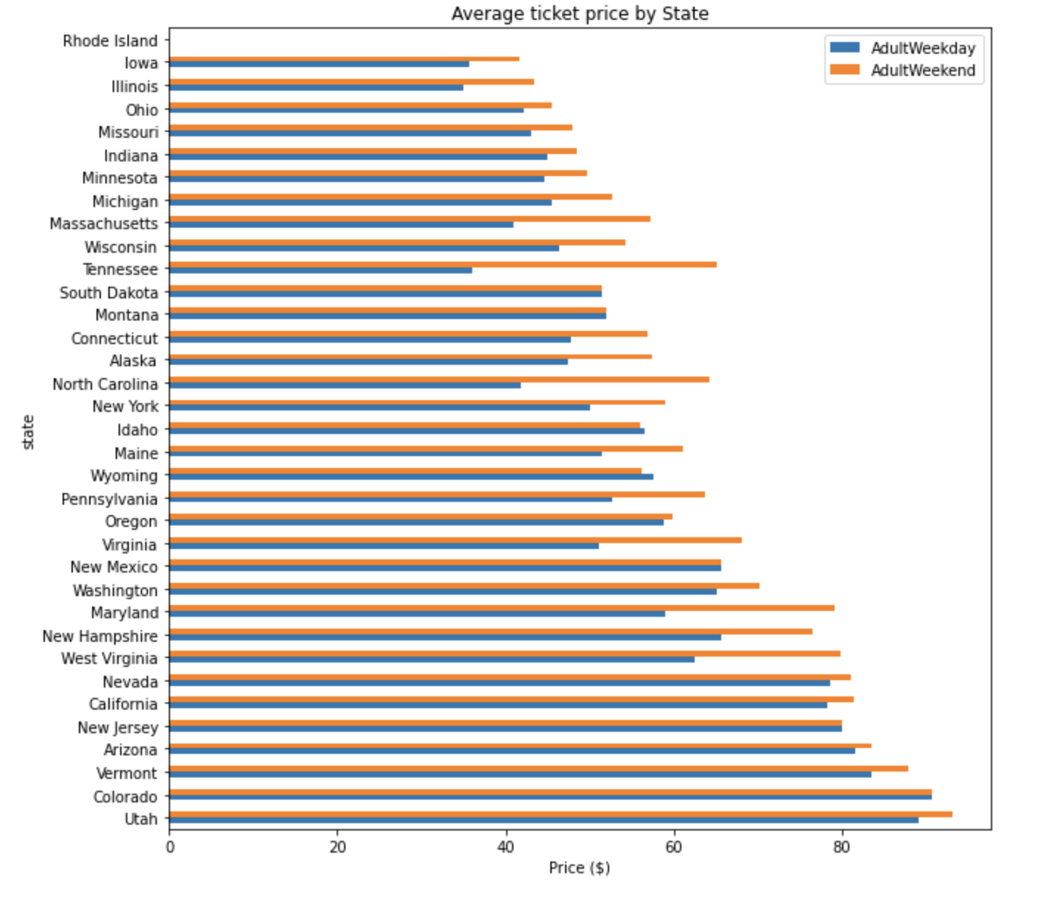

From this initial graph of weekend and weekday ticket prices, we see Montana is one of the few states that does not vary prices according to which day of the week a customer buys a ticket, this is the first indication that there is some room for ticket price increases this season.

Once the data had been cleaned and missing values either dropped or filled in, we wanted to identify which of the variables in the data set highly correlated with ticket prices, to better understand if Big Mountain is capitalizing on the correct marketing and pricing models. The heat map of correlation is below:

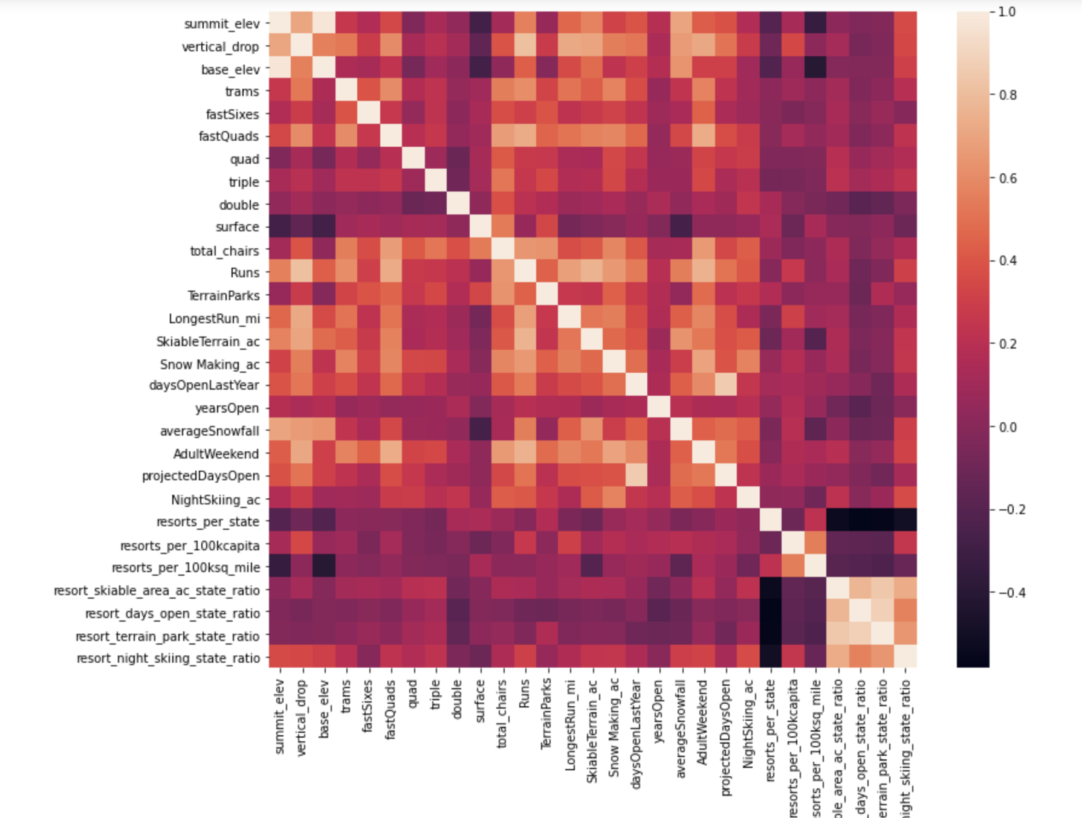

This heat map indicates the variables that correlate with the mean ticket price the most, are vertical drop, fast quads, total chairs, total runs, snow making, as well as days open. We can now make models to best see what if the current pricing model can be increased based on the values Big Mountain has for these price indicative variables. Below are multiple graphs comparing where Big Mountain falls in comparison to market share in a few key variables: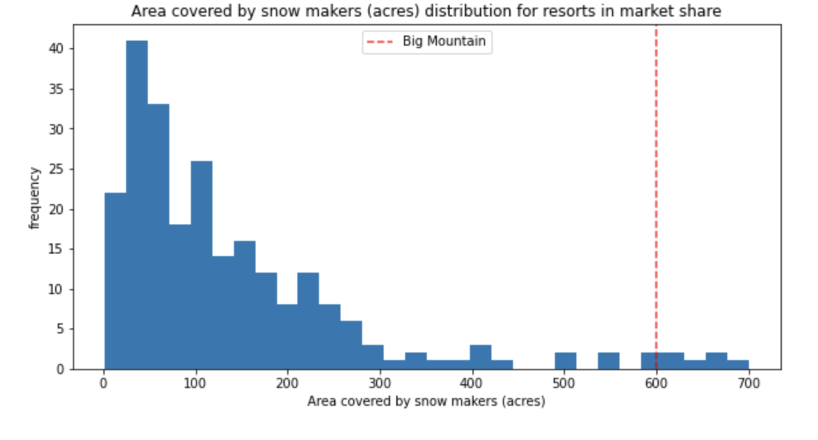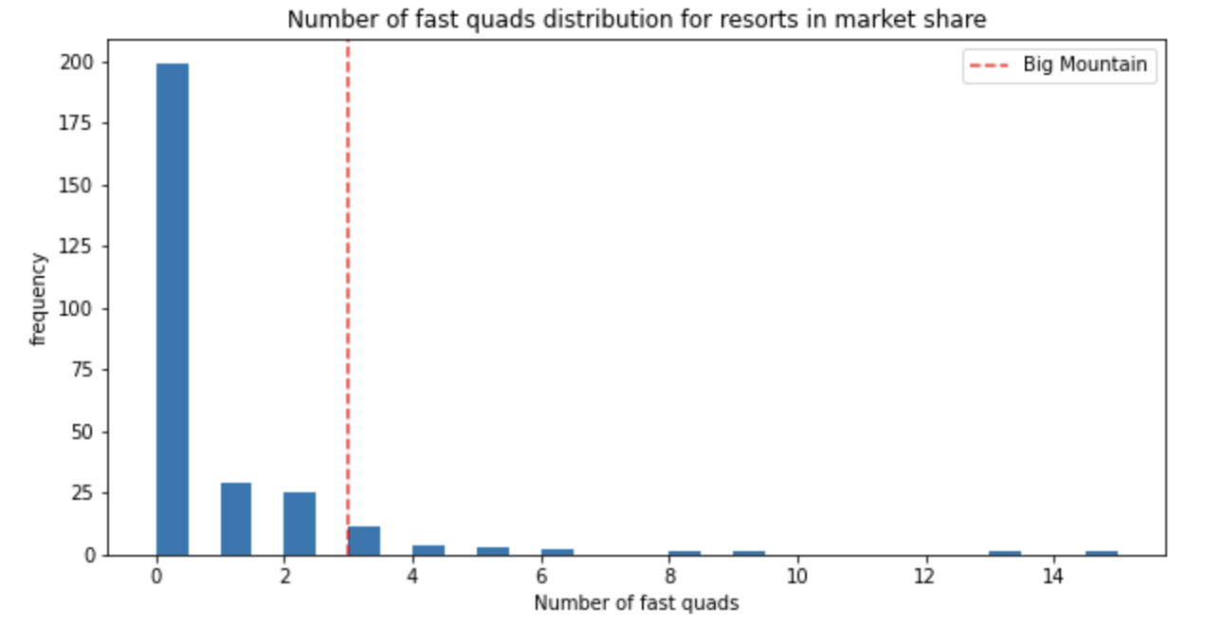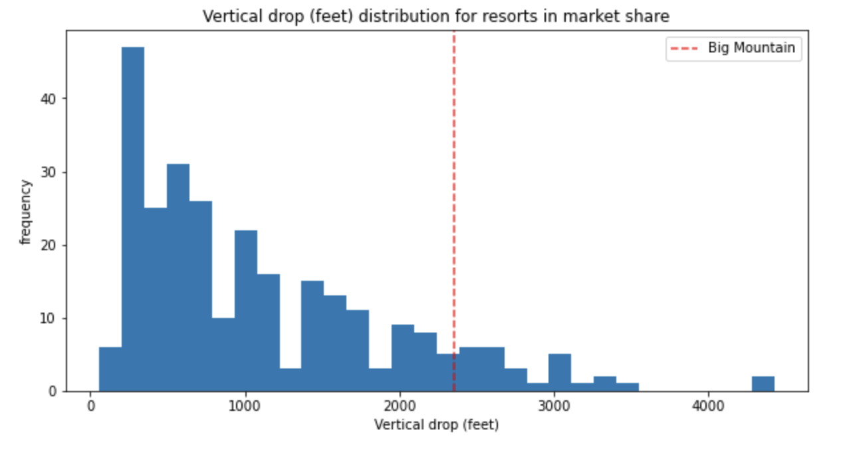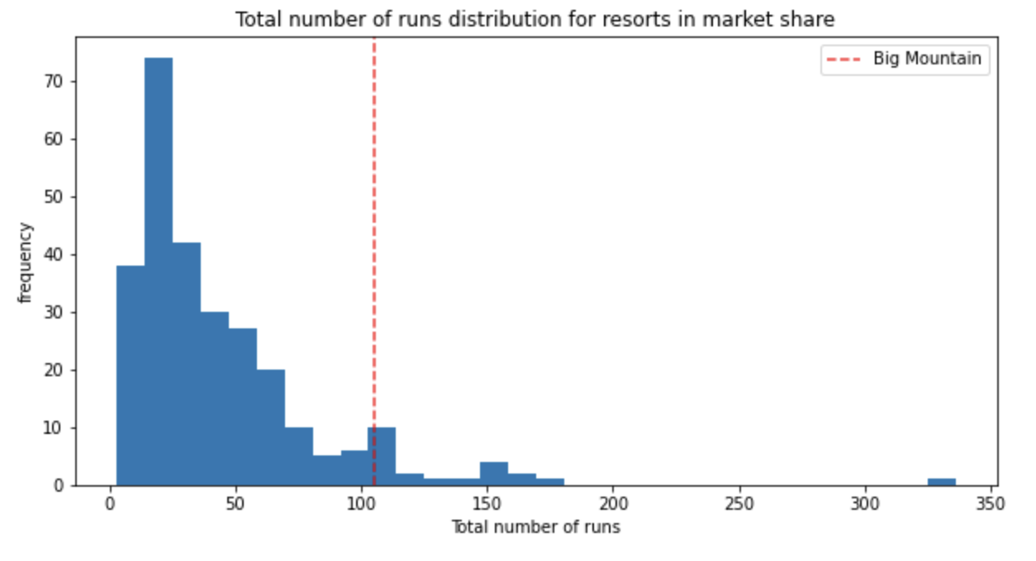

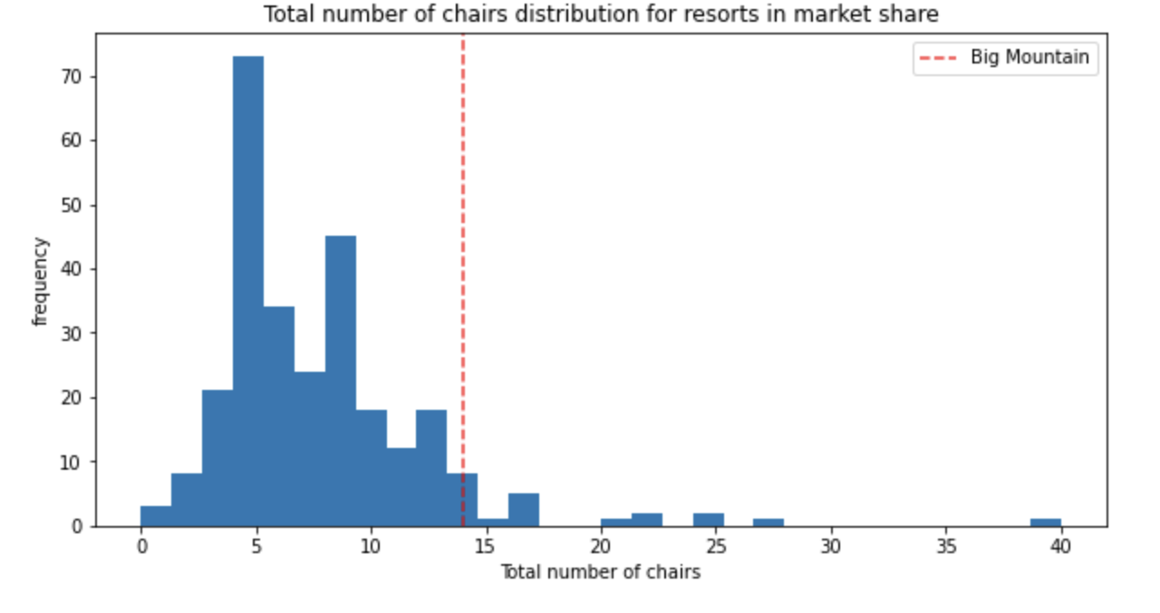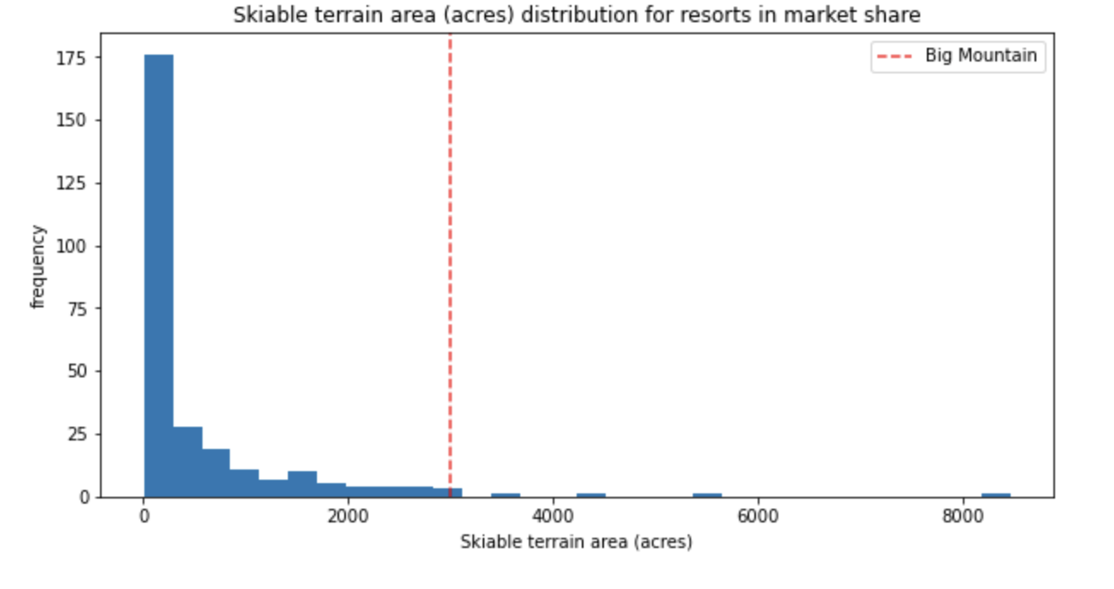

For all of these key variables, Big Mountain is above average as seen in by the red dashed line. Finally, a predictive model was created that takes into account these variables and predicts the available price increase that could be justified. This model also helps to identify if there are variables that could be increased, such as snow making acres, and what the corresponding ticket price could be. 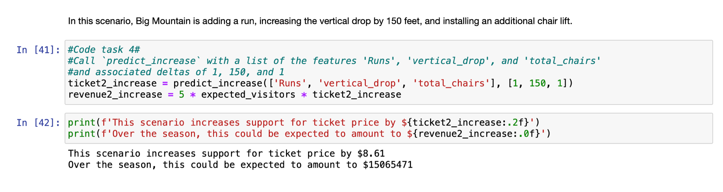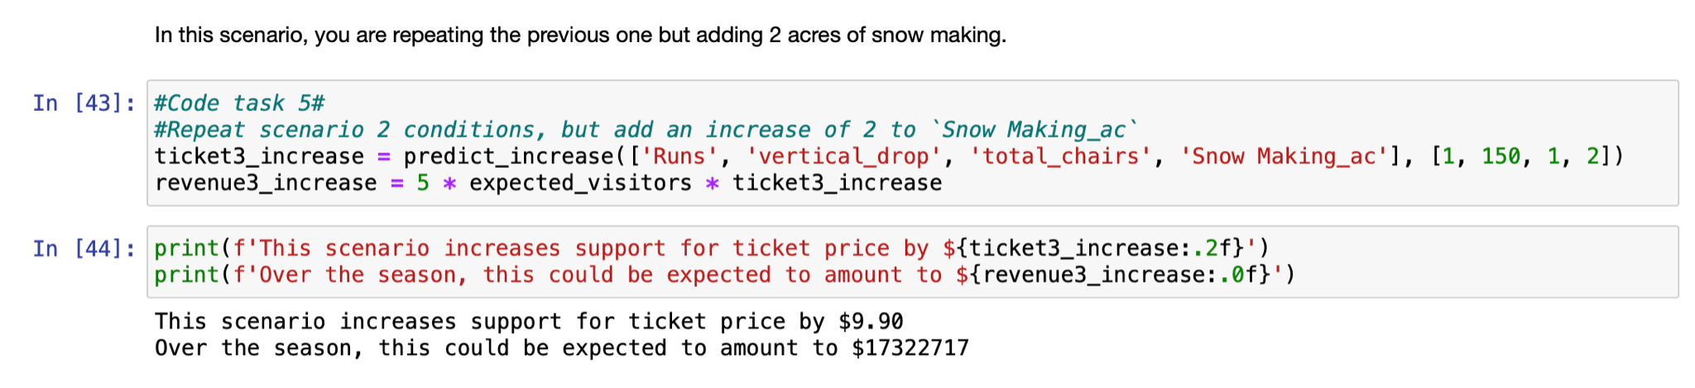

These two code snippets indicate that there is definitely room to increase prices by around 8.61 with current standards, which would lead to a revenue increase of $15,065,471, which would cover the cost of the new lift and encourage resort growth.